1.A Create a file called “awards” in your home directory, containing
JESSE#EISENBERG#THE SOCIAL NETWORK#ACTOR
COLIN#FIRTH#THE KING’S SPEECH#ACTOR
HALLE#BERRY#FRANKIE AND ALICE#ACTRESS
NATALIE#PORTMAN#BLACK SWAN#ACTRESS
DARREN#FINCHER#THE SOCIAL NETWORK#DIRECTOR
ANNETTE#BENING#THE KIDS ARE ALRIGHT#ACTRESS:

First log in as administrator with sudo su command; then go to your home directory with cd command; next create the “awards.txt file with the command cat like this: cat > awards.txt, click an enter and start writing the text, finally end typing with Ctrl + d or Ctrl + c.
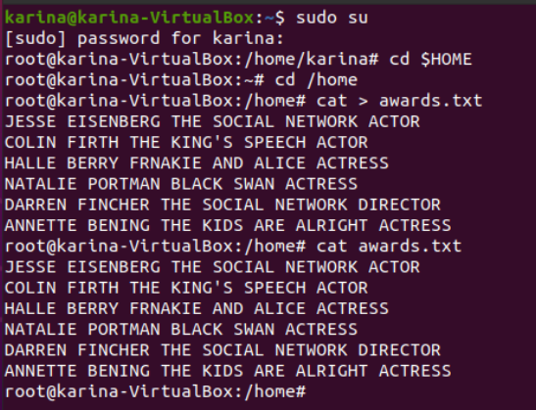

We can do it too without log in as administrator, like this:
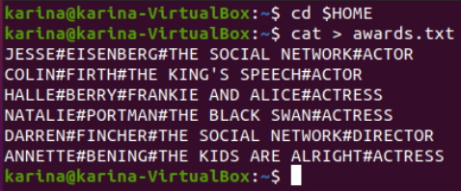

1.B Add a new line, containing CHRISTOPHER#NOLAN#INCEPTION#DIRECTOR, at the end of
the file. You should complete this exercise using commands instead of file editors.
Add the new line with the command cat > > like this: cat > > awards.txt; then click an enter and type the new line and finish with Ctrl + d:
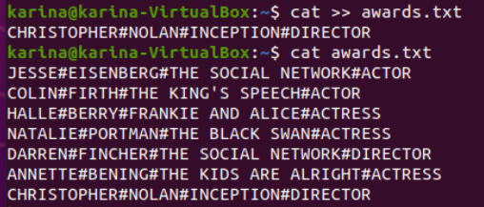

Alternative option:

echo “new text or line” > > awards.txt
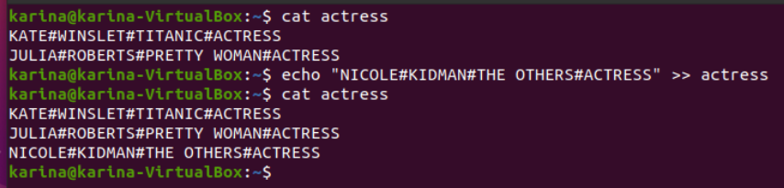
2. Create a file called “actors” in which you only include ACTORS.
With the command cat create the file like this: cat > actors.txt and then show the content with the command cat like this: cat actors.txt:

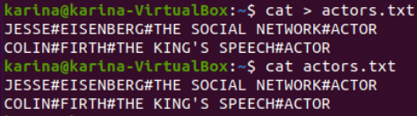

We can use the grep command to create a new file and add an existing line in another file to the new file, like this: grep “#DIRECTOR$” awards > directors:

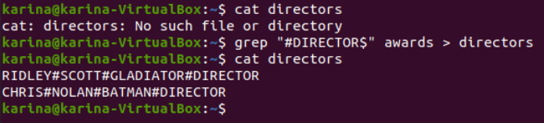
3. Display the files which begin with a in your home directory, with many options:
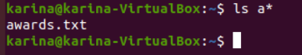

Another one:
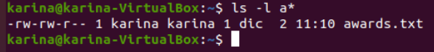

One more:
Last one:
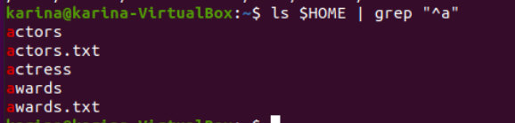

4. Create a file called “directors” in which you only include DIRECTORS.
Again with the command cat we create the new file:
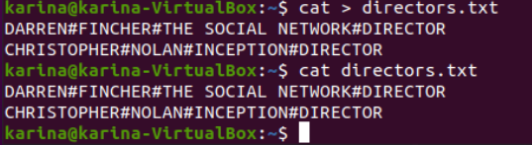

5. Display the lines of “awards” containing actresses. Show the line number.

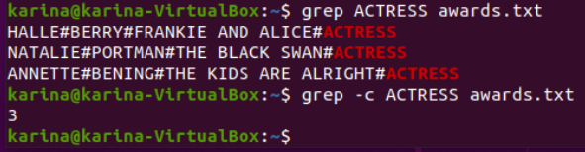

In only one command:
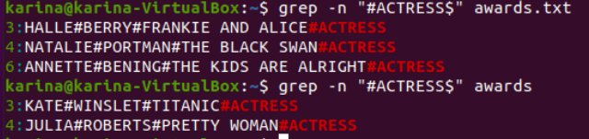
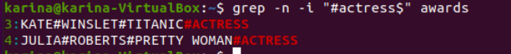
6. Display the lines in “awards” which are not directors. Show the line number.
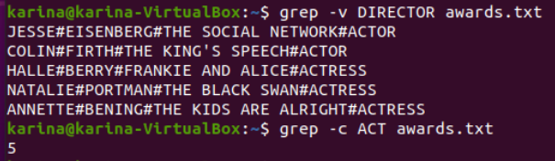

Another option:
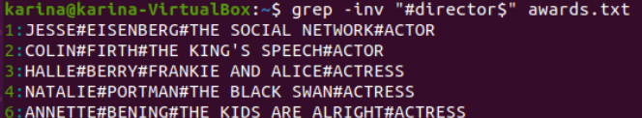
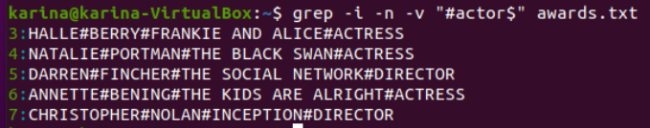

Part 2
Create the file called “people.txt”
Ana;Perrrrrrrales;1000
Pedro;Soria;1600
Jacinto;Manzano;500…..

With the command cat > people.txt:
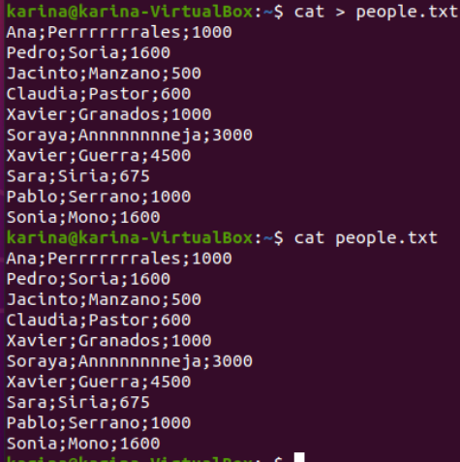

7. Create a file called “people2.txt”, containing those people whose name begins with J or S.
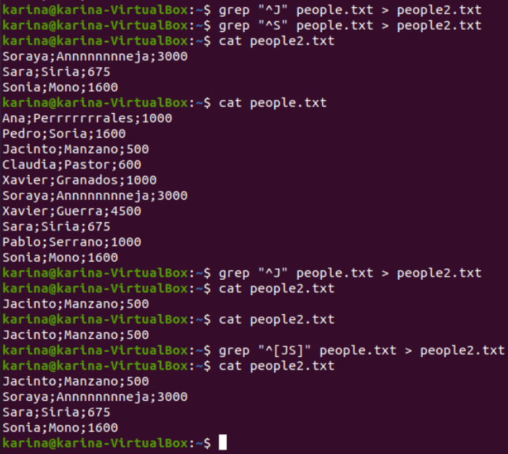
8. Create a file called “people3.txt”, containing those people whose names do not begin with S
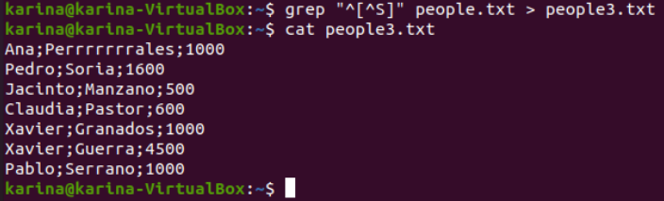

9. Display people whose name begin with S and redirect to file to “people_s.txt”:

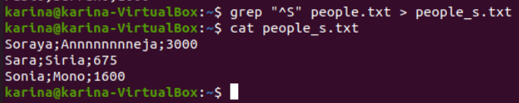
10. Display the number of people whose name begins with A (case insensitive).
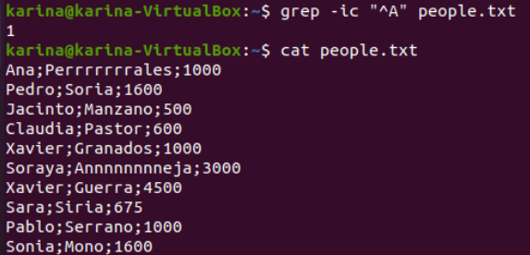

11. Display how many people earn 1000 and concatenate the result in people2.txt

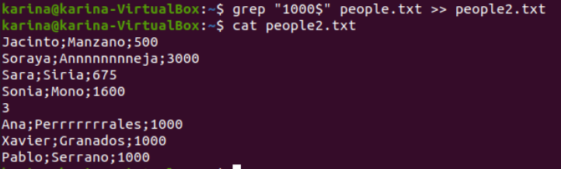

Part 3
12. Create a file called list, including the contents from the current directory
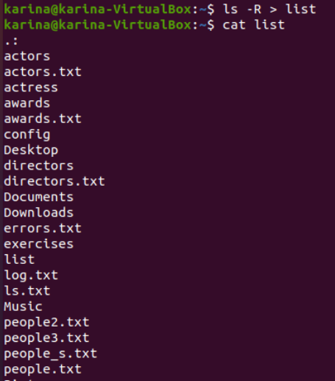

13. Open the file to check if the content is right using cat, more and less and observe the
differences
With cat:
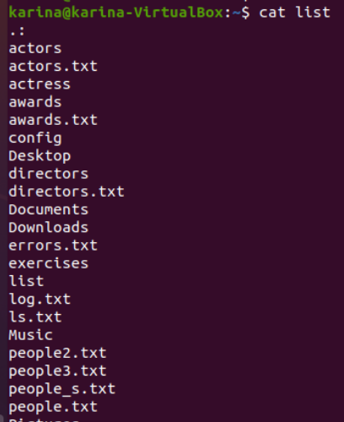

With more:
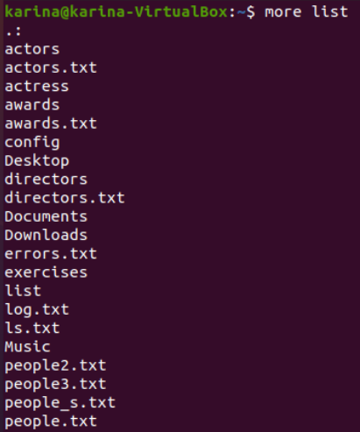
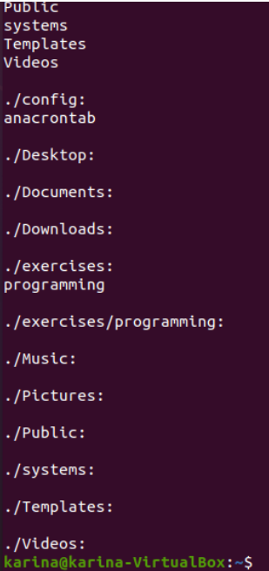

With less:
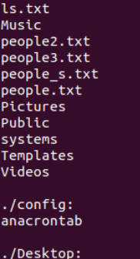
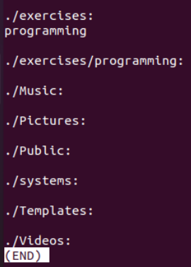

14. Print the contents of the current directory in reverse alphabetical order.

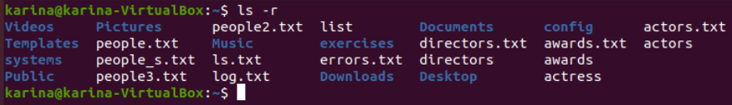
15. Create a file called inform, containing the long format list of the files and directories in
your home directory

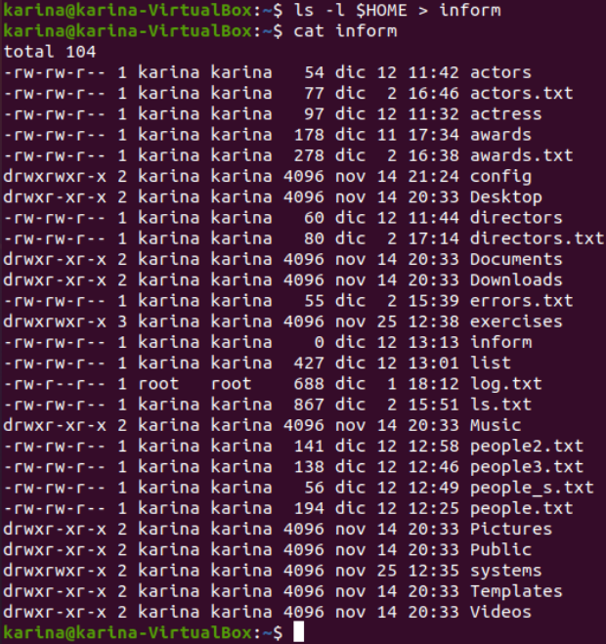

16. Find the word FILE in each file of your home directory, ignoring case and showing the
line number (create files containing this word if you want any match).

I do not how??

